Minnesota Department of Health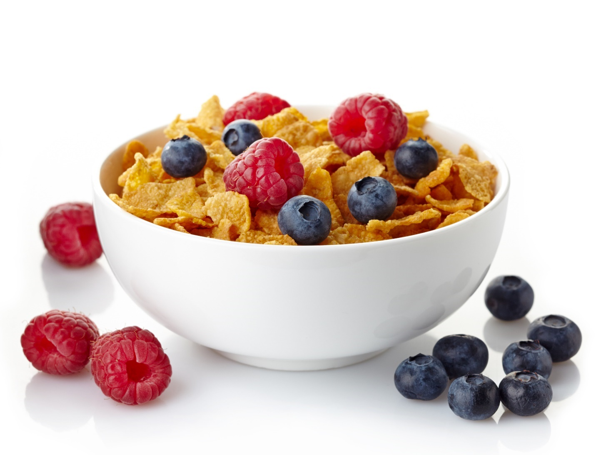WIC Cereal Benefit Recipes

WIC SOcial media toolkit

**For use only by WIC and Local Public Health Agencies in Minnesota**

For questions, please contact:

Minnesota Department of Health  
WIC Program  
PO Box 64882  
St. Paul, MN 55164-0882  
651-201-4404   
[health.wic@state.mn.us](mailto:health.wic@state.mn.us)  
[www.health.state.mn.us](http://www.health.state.mn.us/)

Contents

How to Use This Toolkit 3

What is a “Social Media Toolkit?” 3

Guidance for Local Agencies 3

Creating posts 3

Responding to Comments on Your Posts 4

Research 4

Barriers to breakfast cereal consumption 5

Messages 5

Timing 6

Pictures 8

Using the photos 8

Store photos featuring recipe ingredients 9

Recipe photos and graphic 12

## How to Use This Toolkit

### What is a “Social Media Toolkit?”

This toolkit was designed to make it easy for WIC local agencies to create your own message and pair it with a recipe and photo to post without taking time and resources away from clinic operations. This will help enhance WIC social media presence, sharing important information with current and potential participants. This toolkit provides messages and pictures to support social media efforts promoting WIC cereal benefit utilization. These messages are consistent with MDH’s position, and the pictures are designated for WIC and WIC partner use.

### Guidance for Local Agencies

Select and post any of the content in this toolkit to your agency’s social media pages. You can also use these as a starting point to create your own posts. You can post

You are encouraged to use your own pictures, as long as you have a signed release form giving your agency permission. If you don’t have your own pictures to use, you can select and use images or video links in this toolkit. Please do not edit the MDH pictures.

### Creating posts

* Keep posts short. About three sentences is a good length.
* Include a link, pointing to a website to learn more about the topic. If you’re including a link in an Instagram post, add the link to your profile and the text, “Link in profile” to your post.
* Include the “#MNWIC” hashtag and other relevant hashtags.
  + This makes our posts more visible statewide. Hashtags connect similar conversations, so they are seen by anyone searching for the hashtag.
  + #ThinkOutsideTheBox, #WICCereals, #CerealCreativity, #CerealCreations
* If you’re using your own photos, make sure your photos are clear, well-lit, and match the post.
* Use plain language so your followers understand your message.
* YouTube videos make great Facebook posts. Include a couple sentences addressing the video’s main message and add the YouTube video link. Don’t include a photo because the video preview will show in the post. Select shorter videos to hold your followers’ interest.
* You can pay to “boost” posts so they show up in more newsfeeds. Typically, a user only sees a post if they follow the page, or if one of their friends interacts with the post. Boosting a post displays the post to social media users who meet specified criteria. There are more requirements for posts you choose to boost, and your agency may need to spend time monitoring the post and responding to comments. If you have questions about boosting posts, contact Megan Leonard at [megan.leonard@state.mn.us](mailto:megan.leonard@state.mn.us).

### Responding to Comments on Your Posts

Interacting with your followers is part of the benefits of social media. Take time to answer questions and respond to comments. This will help you reach more people using your social channels.

Unfortunately, unfriendly or biased comments are a part of social media. MDH Communications suggests responding to complaints in a neutral, understanding manner. Be as open as possible and follow your agency’s or county’s social media guidelines.

You should try to respond to comments the same day they are posted. Certain comments don’t need a response, or other Facebook users may provide an adequate response for you. If you need help formulating a response to a question or comment, contact Megan Leonard at [megan.leonard@state.mn.us](mailto:megan.leonard@state.mn.us) for assistance.

## Research

* Recent data from MDH shows that less than 50% (46-49%) of households receiving WIC benefits are using their breakfast cereal benefit (2022).
* Several factors can contribute to a decrease in cereal consumption among WIC recipients including:
  + Dietary preferences - some WIC recipients may prefer other breakfast options or find the available cereals unappealing.
  + Convenience & accessibility - convenience plays a significant role in food choices.
  + Lack of variety - a lack of variety can lead to boredom and decreased consumption.
  + Nutritional concerns - growing consumer attention to added sugars and processed foods.
  + Changes in lifestyle - limited time in the morning due to work, school, or childcare responsibilities makes grab-and-go options easy & attractive.
  + Economic factors - economic constraints can influence food choices and patterns of eating.
* A recent study from Oldways (food & nutrition non-profit) regarding consumption of whole grain (WG) foods found that 26% of consumers want to increase their consumption of WG breakfast cereals.
  + Of those who eat WG foods:
    - 1 in 3 (34%) say WG bread is their favorite.
    - 9% say WG cold cereal is their favorite.
    - Low carb/GF diets on the decline
      * 16% in 2023, 18% in 2022

## Barriers to breakfast cereal consumption

These barriers are based on amodern consumer of child-bearing age and attention to current food trends.

1. Interest in high-protein options.
2. Decrease in dairy-milk consumption.
3. Looking for quick, grab-and-go breakfast options.
4. Concerns about added sugars and processed foods.
5. Unaware of vitamin & mineral content (fortification); importance of this

These barriers can be addressed through a combination of education, accessibility, and community outreach/involvement.

* + Education - providing tidbits of health info.
  + Accessibility - providing recipes using WIC cereals and foods.
  + Community outreach/involvement - social media, in-clinic promotion.

**How the messaging targets these barriers:** messages and accompanying recipes will address one or more of these.

1. Focuses on high-protein options for breakfast, lunch, dinner, or snacks.
2. Focus is on breakfast cereals in a non-traditional format i.e. not just cereal w/ milk in a bowl.
3. Many recipes can be meal-prepped in advance, taken and/or eaten on the go.
4. Focus on utilizing low-sugar cereal options with few ingredients.
5. Messaging addresses iron content & importance of this mineral.

## Messages

These posts are designed for Facebook and Instagram. (Twitter limits posts to 280 characters (links take up 23 of those characters). Instagram cannot link to recipes in the post itself, so you will need to share to stories or link the recipe in your bio.

### Timing

You may post these sporadically or as a month-long campaign; post twice weekly for four weeks. Each week will focus on one of the four key messages (below): grab-and-go, protein specific, iron specific, and homemade any time of day. For each post, select one message and one recipe from each category. Post at different times of the day to engage a wider audience.

The toolkit was designed to be a month-long campaign to really make an impact with the messages.

**Primary message:**

Think outside the box!

**Introductory post:**

Use this post to launch your social media campaign (if you’re posting as a month-long campaign).

Less than half of WIC families used their breakfast cereal benefit last year. We’re going to help you think outside the box!

We get it. Grab-and-go options are easier on busy mornings. Maybe you wonder about cereal’s nutritional value. A bowl of cereal might seem boring.

WIC benefits include cereal for good reasons! Follow us for new ideas and recipes to put your cereal benefit to good use.

**Key messaging:**

The messages incorporate promotion of WIC cereal in general with emphasis on atypical use of the product. Messages and recipes can be combined to form a customized social media post. Select one message from **a.,** add the segue message, and select a recipe for **c.**

1. **Grab-and-go**: Convey the idea that you can prioritize your health even on busy mornings by choosing convenient and nutritious grab-and-go breakfast options that are great for meal-prep (another food trend).
   1. **Messages**
      1. Busy lives deserve healthy mornings.
      2. Morning rush? Fuel up with a nutritious grab-and-go breakfast option!
   2. **Segue message:** This recipe uses cereal purchased with your WIC benefits and offers convenience and nutrition. Start your day right, even when time is short!
   3. **Recipes**
      1. [Apple Peanut Butter Breakfast Cookies (https://www.health.state.mn.us/people/wic/recipes/cereals.html#apple)](https://www.health.state.mn.us/people/wic/recipes/cereals.html#apple)
      2. [Horchata Smoothie (https://www.health.state.mn.us/people/wic/recipes/cereals.html#horchata)](https://www.health.state.mn.us/people/wic/recipes/cereals.html#horchata)
      3. [Peanut Butter & Jelly Granola Bars (https://www.health.state.mn.us/people/wic/recipes/cereals.html#peanut)](https://www.health.state.mn.us/people/wic/recipes/cereals.html#peanut)
2. **Protein specific**: These messages showcase the importance of protein throughout the day to support energy, satiety, and overall well-being.
   1. **Messages**
      1. Good morning, great protein: your recipe for a wonderful day!
      2. Get up, get going, get protein.
      3. Stay fuller, longer with a protein-boosted breakfast or snack.
   2. **Segue message:** Use WIC cereals to amplify your morning routine with a meal that's not just high in protein but also incredibly tasty and satisfying!
   3. **Recipes**
      1. [Southwestern Veggie Egg Bites with Corn Flakes (https://www.health.state.mn.us/people/wic/recipes/cereals.html#southwestern)](https://www.health.state.mn.us/people/wic/recipes/cereals.html#southwestern)
         1. *Another great option for meal-prep & grab-and-go.*
      2. [Yogurt & Fruit Parfait (https://www.health.state.mn.us/people/wic/recipes/cereals.html#fruit)](https://www.health.state.mn.us/people/wic/recipes/cereals.html#fruit)
3. **Iron specific:** In these messages, emphasis is on the importance of iron in maintaining energy levels, supporting overall health & well-being and how cereal purchased w/ WIC benefits can be a delicious and convenient source of this essential nutrient.
   1. **Messages**
      1. The secret ingredient to a strong day: iron in WIC cereals.
      2. For lasting energy, power your day with iron.
   2. **Segue message:** These (recipes or a specific recipe) are quick & tasty and include iron as a bonus, giving your kids energy and boosting their brain development.
   3. **Recipes**
      1. [Spicy Bean Burgers (https://www.health.state.mn.us/people/wic/recipes/cereals.html#spicy)](https://www.health.state.mn.us/people/wic/recipes/cereals.html#spicy)
      2. [Pumpkin Spice Bites (https://www.health.state.mn.us/people/wic/recipes/cereals.html#pumpkin)](https://www.health.state.mn.us/people/wic/recipes/cereals.html#pumpkin)
4. **Homemade any time of day:** These messages emphasize the use of cereal in homemade dishes that can be enjoyed throughout the day.
   1. **Messages**
      1. Wholesome and homemade around the clock!
      2. Breakfast, lunch, or dinner – cereal's versatility knows no bounds!
      3. Bring your family together with homemade foods the whole family will enjoy!
   2. **Segue message:** Pickup this cereal (Cornflakes, Cheerios, etc.) with your WIC benefits and make these for your family today!
   3. **Recipes**
      1. [Cornflake Mozzarella Sticks (https://www.health.state.mn.us/people/wic/recipes/cereals.html#baked)](https://www.health.state.mn.us/people/wic/recipes/cereals.html#baked)
         1. Serve with tomato sauce simmered with oregano, salt & pepper.
      2. [Veggie Corn Fritters (https://www.health.state.mn.us/people/wic/recipes/cereals.html#veggie)](https://www.health.state.mn.us/people/wic/recipes/cereals.html#veggie)
      3. [Sweet Cinnamon O’s Bars (https://www.health.state.mn.us/people/wic/recipes/cereals.html#sweet)](https://www.health.state.mn.us/people/wic/recipes/cereals.html#sweet)
         1. An excellent source of iron.

## Pictures

These photos are available for the Minnesota WIC program and its local agencies to use. Email [health.wic@state.mn.us](mailto:health.wic@state.mn.us) if you have questions regarding photo usage outside of your local agency.

### Using the photos

* Right click the photo you want to use and select “save as.”
* Save the photo to your desktop or other location.
* When you open the saved photo it will display in its original size and quality. Do not alter the pictures.

### Store photos featuring recipe ingredients

Cereal aisle featuring shelves filled with different kinds of Cheerios.
 Cereal aisle in store featuring grape nuts, kellog cereal, Kashi cereal, etc.
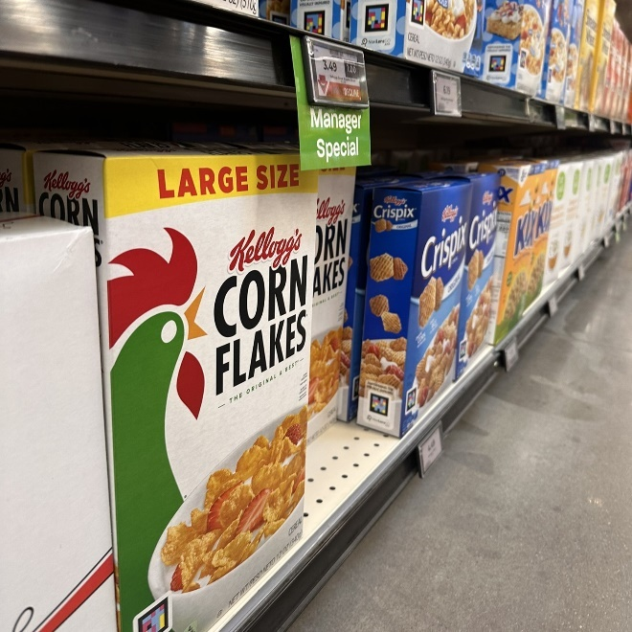 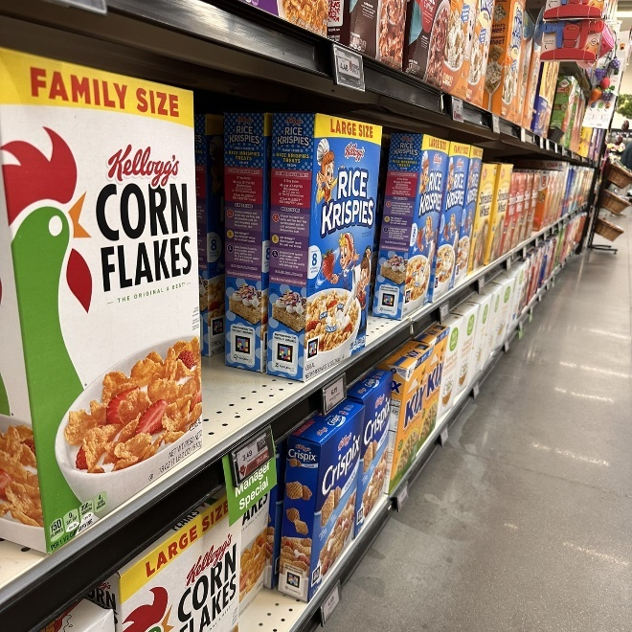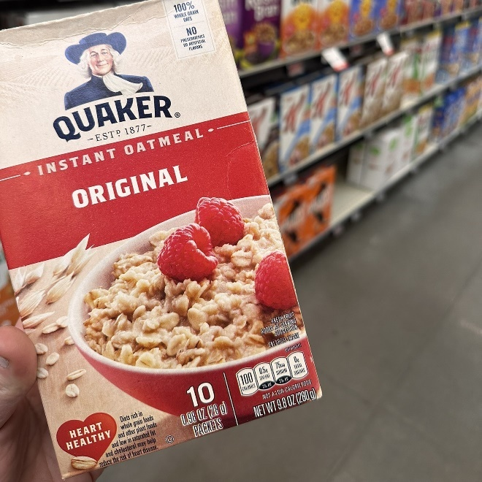 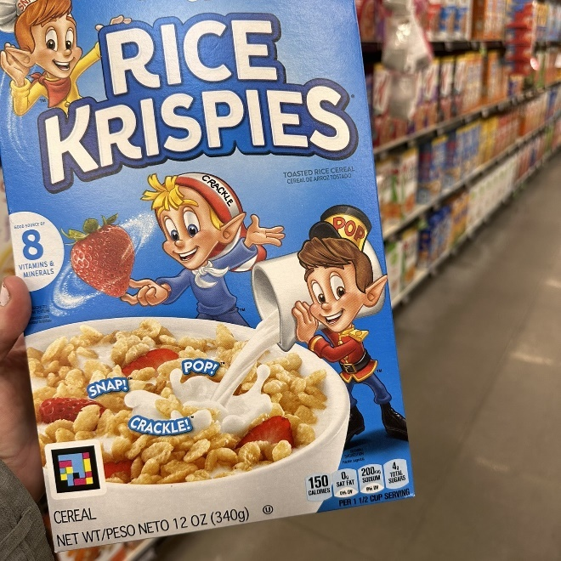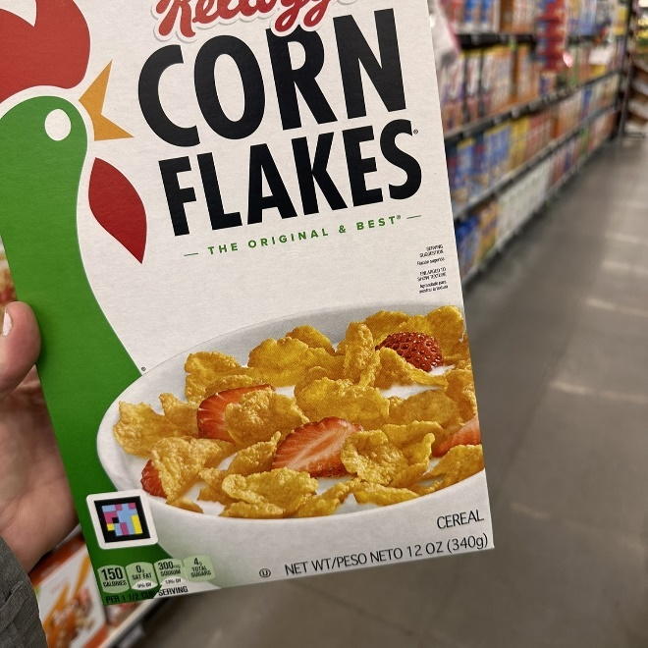 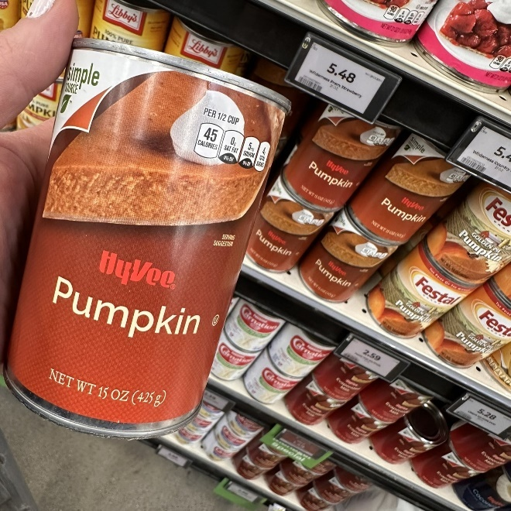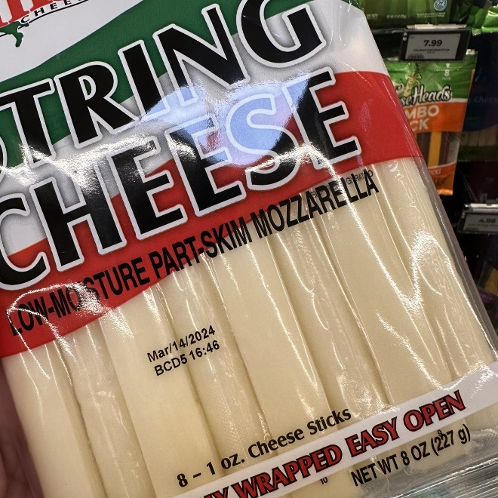

### Recipe photos and graphic

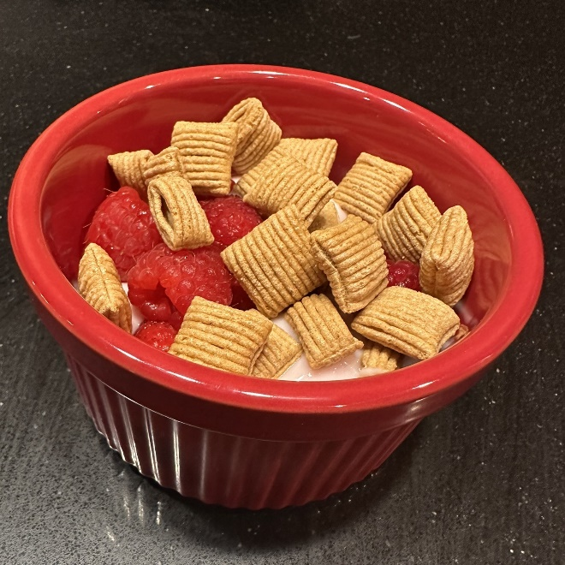 Graphic featuring text: 

Spicy bean burgers. 
Ingredients
-crisp rice cereal (WIC allowed)
-Canned pinto beans (WIC allowed) 
-Egg
-Chili powder
-Salt
-Onion or bell pepper (WIC allowed)
-Vegetable oil
Full recipe online health.state.mn.us/wic 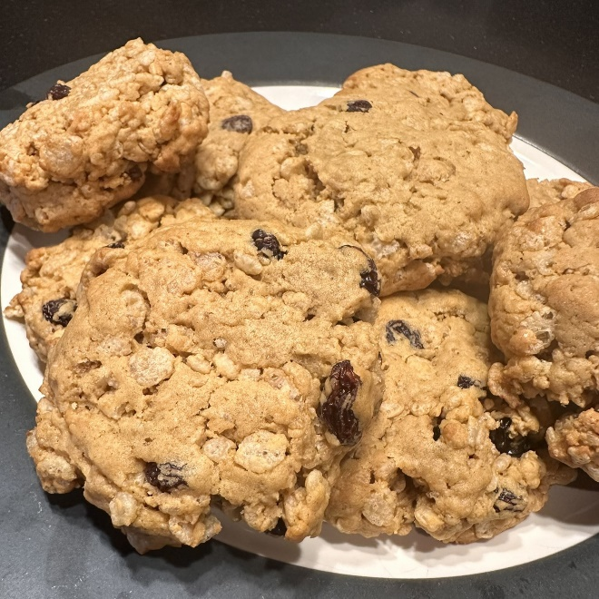 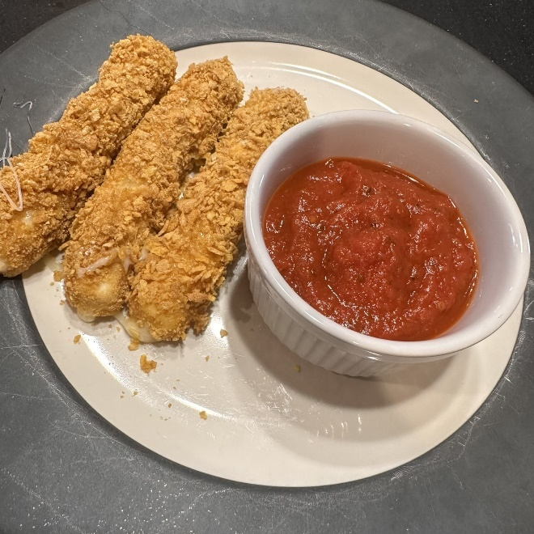 Plate with three baked mozzarella sticks, with a piece in a hand dipped in marinara sauce.
 Pumpkin spice balls on a plate


