Sample Newsletter Article for Long-term Care Facilities

Antibiotic Stewardship at [FACILITY NAME]

Here at [FACILITY NAME], we take antibiotic use very seriously, so we are pleased to let you know that we have an antibiotic stewardship policy and program. Antibiotic stewardship is the practice of improving antibiotic use.
Although antibiotics save lives when used to treat bacterial infections, antibiotics won’t work for viruses such as a cold or flu and many urinary tract conditions. When antibiotics aren’t needed, they won’t help you, and the side effects could hurt you. Common side effects are dizziness, nausea, diarrhea, yeast infections, and allergic reactions.
Along with serious side effects, unnecessary antibiotics lead to antibiotic resistance. Antibiotic resistance is when bacteria develop ways to withstand antibiotics. These resistant bacteria can spread to you and your loved ones. The CDC estimates that 2 million people get resistant infections yearly in the U.S. and 23,000 die as a result.

[FACILITY NAME] is taking action to make sure that our residents get the best care. Our antibiotic stewardship program goals include:
- making sure residents get antibiotics only when necessary—for bacterial infections, and
- making sure residents get the right antibiotic, at the right time, for the right length of time.
What can you do? Ask three questions before you take antibiotics:

- Do I really need antibiotics? Antibiotics treat bacterial infections. Ask whether you have a bacterial infection.
- What are the risks? Antibiotics can cause side effects like nausea and diarrhea and lead to antibiotic resistance.
- Are there other options to help me feel better? Rest and plenty of fluids are important, and ask about over-the-counter medicines that might help relieve your symptoms

Please let us know if you have questions or concerns about antibiotic use at [Facility Name].
Thank you for supporting this important work!
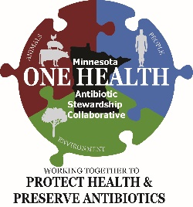
Minnesota Department of Health
PO Box 64974
St. Paul, MN 55164-0975
651-201-5414 | 1-877-676-5414
www.health.state.mn.us

