Basic Room Setup for Administrative Hearing

Note: Provide microphones for judge, agency representatives, and speakers
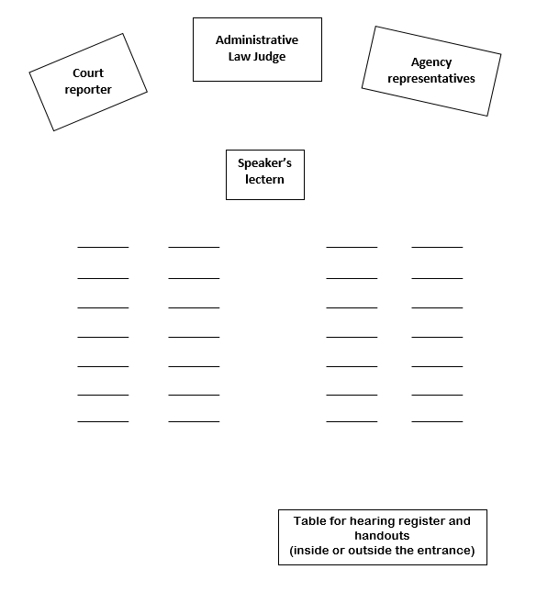
Suggested Room set up for an Administrative Hearing: Facing the front of the room, the Court Reporter is to the left, the Administrative Law Judge is in the center, and the Agency representatives are to the right. The Speakers lectern is in front of the audience, lined up with the Administrative Law Judge. There is also a table for hearing registration and handouts at the back of the room. This can be inside or outside of the room.

