Minnesota Department of Health

# Attachment F: Application Evaluation Scoring Criteria Minnesota Drug Overdose Prevention Grant Program - TOWN

A numerical scoring system will be used to evaluate eligible applications. Scores will be used to develop final recommendations. Applicants are encouraged to score their own application using the evaluation scoresheet before submitting their application. This step is not required but may help ensure applications address the criteria evaluators will use to score applications.

## Rating Levels

| Rating or Score | Description |
| --- | --- |
| Excellent or 5 | Outstanding level of quality; significantly exceeds all aspects of the minimum requirements; high probability of success; no significant weaknesses. |
| Very Good or 4 | Substantial response: meets in all aspects and in some cases exceeds, the minimum requirements; good probability of success; no significant weaknesses. |
| Good or 3 | Generally, meets minimum requirements; probability of success; significant weaknesses, but correctable. |
| Marginal or 2 | Lack of essential information; low probability of success; significant weaknesses, but correctable. |
| Unsatisfactory or 1 | Fails to meet minimum requirements; little likelihood of success; needs major revision to make it acceptable. |

## Scoring Selection – Scored up to 100 points

| **Proposal Components** | **Possible Points** |
| --- | --- |
| 1. Attachment A - Executive Summary | 5 |
| 2. Attachment A – Organizational Capacity | 15 |
| 3. Attachment A – Project Design, Implementation, and Performance Measurement | 25 |
| 4. Attachment A – Equity, Focus Populations, and Cultural Competence | 30 |
| 5. Attachment B - Workplan | 20 |
| 6. Attachment C - Budget | 5 |
| Total: | 100 points |

## Priority Populations/Geographical Areas:

* People who use drugs.

People who inject drugs.

People who live in areas disproportionately impacted by overdose (Northwest, Northeast, Metro regions of Minnesota).

* + See map below for additional information regarding overdose rates.

American Indian/Alaskan Native, Black/African American Minnesotans.

Justice-involved populations.

People experiencing homelessness.

Map of Minnesota with Nonfatal Overdose Rate by Region

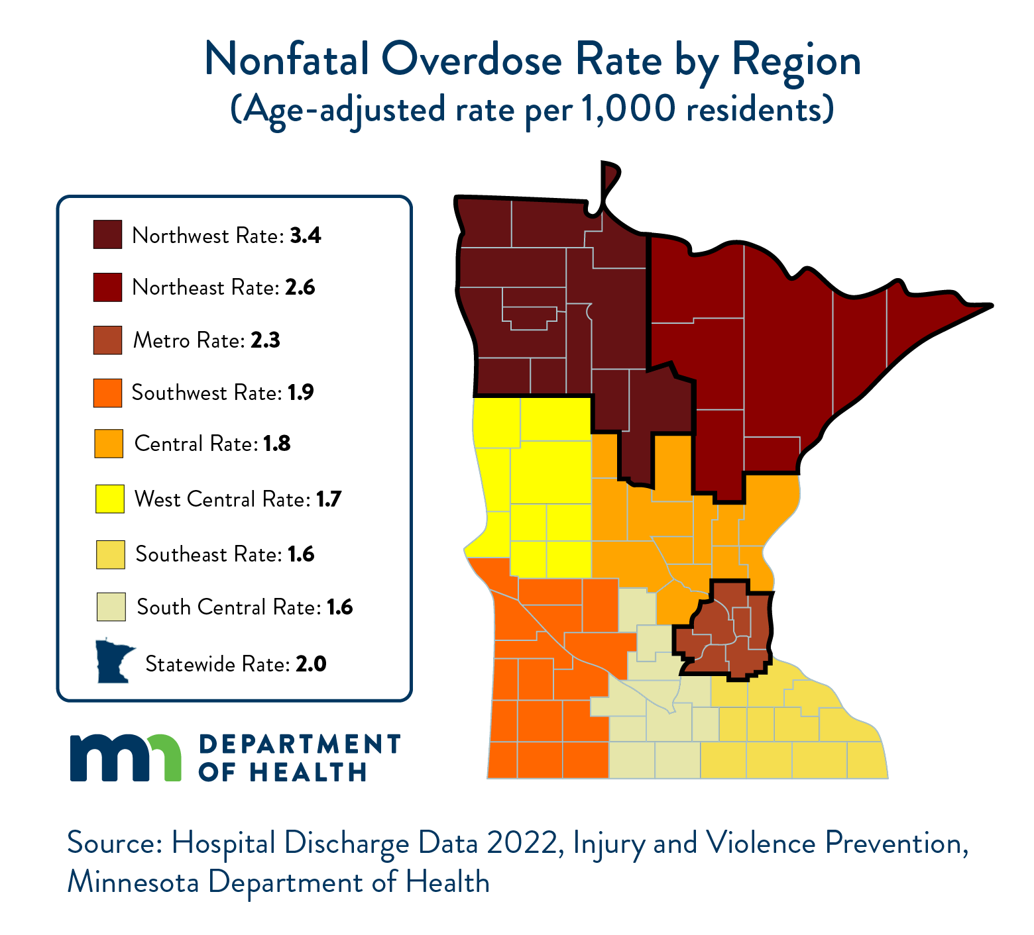

Nonfatal Overdose Rate by Region (age-adjusted per 1,000 residents) Source: Hospital Discharge Data 2021,   
Injury and Violence Prevention, Minnesota Department of Health.   
Northwest Rate: 3.4; Northeast Rate: 2.6; Metro Rate: 2.3; Southwest Rate: 1.9; Central Rate: 1.8; West Central Rate: 1.7; Southeast Rate: 1.6; South Central Rate: 1.6; Statewide Rate: 2.0.

### Attachment A: Executive Summary (5 Points)

| Criteria | Score (1 -5) |
| --- | --- |
| The applicant organization clearly describes the following:   * Project goal(s) * Anticipated number of individuals to be served over the life of the project * Focus population (score higher for priority populations) * Geographical area to be served (score higher for priority areas) | X |

### Attachment A: Organizational Capacity (15 Points)

| Criteria | Score (1 -5) |
| --- | --- |
| The applicant organization clearly describes the following:   * History * Geographical reach, i.e., county, cities, region served (score higher for priority geographical locations) * Number of unduplicated people served by the applicant organization in 2023, if applicable * Demographics of those served in 2023 (score higher for priority populations), if applicable * The applicant demonstrates skill and experience of staff/staff roles providing the proposed services to the population of focus | X |
| The applicant organization currently provides similar services that are directly relatable to the activities outlined in the grant proposal. They are well positioned and experienced in providing the proposed services to the population of focus. | X |
| The applicant demonstrates past achievements in similar programming which complement and/or are a natural extension of the proposed project. | X |

### Attachment A: Project Design, Implementation, and Performance Measurement (25 Points)

| Criteria | Score (1 -5) |
| --- | --- |
| The applicant organization clearly outlines the activities of the proposal. The activities align with the ultimate prevention of drug overdose. The applicant clearly demonstrates what services they offer internally, and which will be offered via partnerships, *if applicable.* They have or will have partnerships/collaborations in place to provide the proposed services to the identified focus population*, if applicable.* | X |
| The applicant organization identifies a problem related to the drug overdose epidemic and the disproportionate impact it has had on different geographical and/or racial/ethnic/cultural communities in Minnesota. | X |
| The applicant organization has clearly defined outcomes (objectives) that are attainable during the 4-year grant period and document an intended change(s) among the population of focus (not focused on what the organization will achieve). The outcomes are in alignment with the overall goal of reducing overdose deaths in MN. | X |
| The applicant has developed a plan to document qualitative and quantitative data. The applicant describes the process of how data will be collected and stored and any tools that will be used to support program data collection. | X |
| The applicant has clearly described how program data will be used to guide decision making throughout the project. The applicant describes how data findings will be reviewed and shared with relevant staff, community partners, and/or the impacted community. | X |

### Attachment A: Equity, Focus Populations, and Cultural Competence (30 Points)

| Criteria | Score (1 -5) |
| --- | --- |
| The applicant has identified a focus population(s) and/or a geographical region at higher risk for non-fatal overdose.   * People who use drugs * People who inject drugs * Areas of MN disproportionately impacted by overdose (**Northwest, Northeast, Metro**) * American Indian/Alaskan Native and Black/African American Minnesotans * Justice-involved Minnesotans * People experiencing homelessness | X |
| The applicant demonstrates skills and experience providing culturally responsive services to the focus population(s) being served or that will be served. | X |
| The applicant has clearly laid out a plan to ensure culturally responsive services will be provided under this grant proposal. The applicant’s proposed activities are aligned with the cultural practices and values of the intended service population. | X |
| The applicant demonstrates that they partner (or will partner) with the community they intend to serve to design, implement, and evaluate policies, practices, and services to ensure cultural and linguistic appropriateness. | X |
| The applicant has demonstrated that they can provide services in a language(s) other than English. These language skills are directly relatable to the focus population. | X |
| The applicant shows a strong history of working to eliminate health disparities and advancing health equity for the identified focus population. | X |

### Attachment B: Work Plan (20 Points)

| Criteria | Score (1 -5) |
| --- | --- |
| The applicant organization has provided a clearly defined long-term goal(s) which establishes a connection between the problem/priorities and the applicant’s intentions. | X |
| The applicant organization has clearly defined objectives which are attainable given the project design. The objectives are clear, measurable, attainable, and achievable. The objectives are focused on the focus population (not focused on what the organization will do). The objectives should pertain to what will happen within the focus population, not what the organization will “do”. | X |
| The applicant organization has demonstrated action steps (activities) that are comprehensive and clearly describe and how they will support the identified objectives. Included for each activity is a description of the anticipated outcome and evaluation measures (as applicable). Applicant also includes expected timeline and staff/partners who will be involved in the activity. | X |
| The applicant organization has embedded evaluation into the workplan to assess the impact of the proposed project and collect the required data tracking requirements. | X |

### Attachment C: Budget Spreadsheet (5 Points)

| Criteria | Score (1 -5) |
| --- | --- |
| The budget detail and justification/narrative are clear and provide a description of how funds will be used for the grant period. The expenses will contribute to the project goal(s). The expenses included in the budget detail and justification support activities outlined in the work plan. The narrative detail in the budget provides detail of how the budget numbers were determined. | X |

Minnesota Department of Health  
Drug Overdose Prevention Unit  
PO Box 64975  
St. Paul, MN   
55164

<https://www.health.state.mn.us/communities/opioids/mnresponse/preventionrfp/index.html>

[health.preventionrfp@state.mn.us](mailto:health.preventionrfp@state.mn.us)

02/06/2024

To obtain this information in a different format, call: 651-201-5400.