For More Information
If you have questions about copper in drinking water, please call us at: ___- ___-____
Visit our website at: _______________
Visit the Minnesota Department Health’s Copper in Drinking Water (https://www.health.state.mn.us/communities/environment/water/contaminants/copper.html).
This notice is being sent to you by
[Insert name of water system]
PWSID ___
Date Distributed: __/__/____
Important Information about Copper in
Your Drinking Water
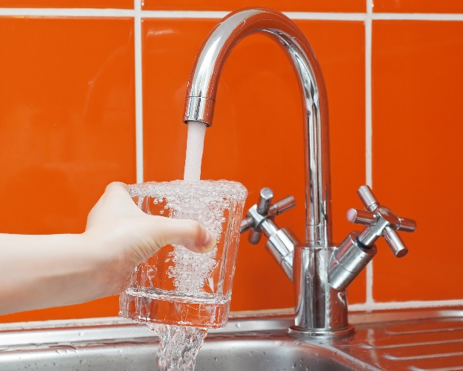
[Insert name of water system]
has found elevated levels of copper in drinking water in some homes/buildings.
Please read this information closely to see what you can do to reduce copper in your drinking water.

Elevated Levels of Copper in Your Drinking Water
Our water system regularly samples for copper in our drinking water to make sure it meets Safe Drinking Water Act standards.
More than 10 percent of the locations sampled for copper were above the Safe Drinking Water Act action level for copper. The action level for copper is 1,300 micrograms per liter (the same as 1,300 parts per billion, or ppb).
What Are We Doing about the Issue?
We are looking at ways to reduce copper in our drinking water. We are also adopting a copper education program for all of our water customers. [You may add more information about what your water system is doing.]
What Are the Health Effects of Copper?
Your body needs some copper to stay healthy, but too much is harmful. Eating or drinking too much copper can cause vomiting, diarrhea, stomach cramps, nausea, liver damage, and kidney disease. The level of copper that will cause symptoms varies from person to person. Nausea and diarrhea may occur when copper levels are approximately 3,000 ppb.
Most people’s bodies are able to maintain the right level of copper. People with Wilson’s disease and some infants (babies under one year old) are sensitive to copper. Their bodies are not able to get rid of extra copper easily.
Sources of Copper
Copper is a reddish metal that occurs naturally in rock, soil, water, sediment, and air. It is used to make many products, including parts for plumbing systems.
Copper can get into your drinking water as the water passes through your plumbing system. Over time, plumbing parts usually build up a natural coating that keeps the water from absorbing copper from the plumbing.
Water may have more copper if:
  - Your plumbing is less than three years old. It likely has not had time to build up a protective coating.
  - It has been sitting in your pipes. The water has had more time to absorb copper from the plumbing.
  - You use warm or hot water. Warmer water absorbs more copper from plumbing systems.
  - You have a water softener. There may be less protective coating with softened water.
Reducing Exposure to Copper in Water
- Let the water run before using it for drinking or cooking. If you have a lead service line, let the water run for 3-5 minutes. If you do not have a lead service line, let the water run for 30-60 seconds.
  - Ways to let the water run before using it for drinking or cooking:
    - Do tasks like showering or running the dishwasher first
    - Collect tap water for cleaning or watering plants
  - Make sure you let the water run from individual faucets for a short time before using them for drinking or cooking.
  - Consider keeping a container of drinking water in the refrigerator to reduce how often you need to let the water run.
- Use cold water for drinking, making food, and making baby formula. Hot water releases more copper from pipes than cold water.
- Test your water. In most cases, letting the water run and using cold water for drinking and cooking should keep copper levels low in your drinking water. If you are still concerned about copper, arrange with a laboratory to test your tap water.
  - Testing your water is important if an infant or someone with Wilson's disease drinks your tap water
  - Search for Accredited Laboratories (https://eldo.web.health.state.mn.us/public/accreditedlabs/labsearch.seam) to purchase a sample container and get instructions on how to submit a sample.
  - [If your water system offers testing, include your contact information and anything else, such as if you provide free testing. You could also refer to other labs in your area that are certified to do water testing for lead.]
- If tests show you have levels of copper over 1,300 ppb in your tap water after you let the water run 30-60 seconds, you may want to consider treating your water.
  - If you use a water softener, ensure that your softener settings are correct. Some treatments can increase copper levels in water.
  - You can learn more about water treatment options at Home Water Treatment (https://www.health.state.mn.us/communities/environment/water/factsheet/hometreatment.html).

