e. Instructions for Donning and Doffing PPE:
HCID Level 1
HIgh consequence infectious disease (HCID) Readiness binder
The following HCID Level 1 full barrier isolation personal protective equipment (PPE) is adapted from CDC guidance. It applies to PPE used for the following situations:
- A health care provider (HCP) caring for patients with a high consequence infectious disease (HCID) that is spread by the airborne route (e.g., MERS, SARS, pandemic influenza)
- A health care provider caring for patients who are persons under investigation (PUIs) for Ebola or other viral hemorrhagic fever (VHF) who are clinically stable and do not have bleeding, vomiting, or diarrhea. There is a lower risk of splashes and contamination in these situations.
- A person acting as the trained observer for a health care provider who is doffing HCID Level 2 PPE.
- A person acting as the doffing assistant who is helping a health care provider with doffing HCID Level 2 PPE.
These instructions are for PPE with a gown ensemble only. If coveralls are to be worn, these instructions can be edited by the facility to match CDC’s For U.S. Healthcare Settings: Donning and Doffing Personal Protective Equipment (PPE) for Evaluating Persons Under Investigation (PUIs) for Ebola Who Are Clinically Stable and Do Not Have Bleeding, Vomiting, or Diarrhea (https://www.cdc.gov/vhf/ebola/healthcare-us/ppe/guidance-clinically-stable-puis.html).
Facilities can rebrand and modify the instructions and images to match facility processes and guidelines.

Supplies Needed
- Fluid-resistant gown extending to mid-calf or a coverall (ANSI/AAMI level 3)
- Extended cuff gloves (appropriate size)
- 2 pairs for suspected VHF
- 1 pair for suspected respiratory HCID
- Surgical face mask, N95 respirator, or PAPR
- Full face shield
- Hair cover and booties are optional
- Any alcohol-based hand rub (ABHR) product that has greater than 60% alcohol

Additional Donning Tips
- Different color gloves can be helpful to identify a situation where one glove is accidentally removed or damaged
- A mirror can be useful for the HCP while donning PPE
- A trained observer can be helpful for donning HCID Level 1 PPE

Donning Instructions

Remove personal clothing and items
- HCP should wear surgical scrubs.
- No personal items should be worn under PPE or brought into the patient room (e.g., rings and other jewelry, watches, cell phones, pagers, pens).
- Long hair should be tied back.
- Eye glasses should be secured with a tie.

Visually inspect PPE prior to donning
- All required PPE and supplies are available.
- PPE is in serviceable condition (e.g., not torn or ripped).
- Selected PPE sizes are correct for the HCP (e.g., gown to mid-calf, gloves fit).

Don protective booties (optional)

Perform hand hygiene
- Perform hand hygiene with alcohol-based hand rub (ABHR).

Don inner gloves with extended cuffs for suspected VHF HCID

If only using a single pair of gloves for a suspected respiratory HCID, wait until step 9 to don gloves

Don gown (ANSI/AAMI level 3)
- Ensure gown is large enough to allow unrestricted movement.
- Ensure cuffs of inner gloves are tucked under gown sleeves.
- Ensure gown length goes to mid-calf.
- Secure all ties and fasteners.
- The trained observer will make any needed adjustments.

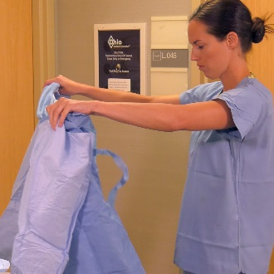
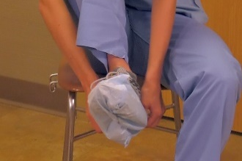
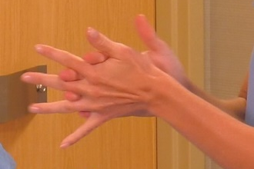
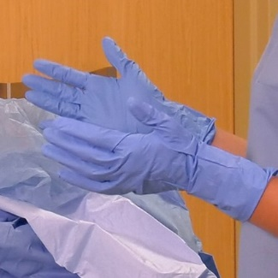

Don facial protection
- Surgical face mask can be used in place of respirator for clinically stable PUIs for VHF (per CDC guidance).
- A respirator should be used if respiratory HCID is suspected
(i.e., MERS, SARS, pandemic influenza).
  - N95: Don and complete a respirator seal check.
  - PAPR: skip to step 9.

Don hair cover (optional)
- It should cover all hair and the ears.

Don outer gloves with extended cuffs for VHF HCID

Don single pair of gloves for respiratory HCID
- Ensure cuffs are pulled over gown sleeves.

Don full face shield or PAPR
- Put on full face shield over the surgical face mask or N95 respirator to protect the eyes as well as front and sides of the face.
- If using PAPR, don at this point. Face shield is integrated.

Verify
- HCP (and trained observer if present) verify the integrity of the PPE ensemble (e.g., no cuts or tears).
- HCP should be comfortable and able to go through a range of motion (e.g., extend arms, bend at waist) and remain correctly covered.
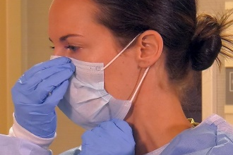
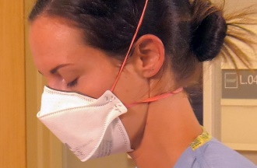
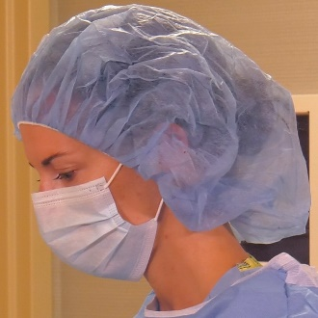
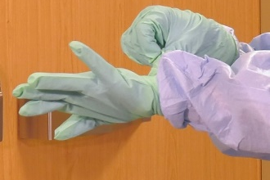
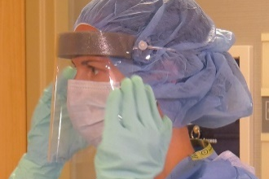
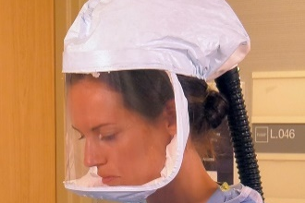
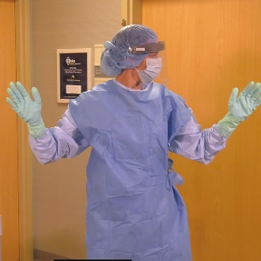

Doffing Instructions
- PPE should be doffed in the designated PPE removal area.
- As with all PPE doffing, meticulous care should be taken to avoid self-contamination.
- A trained observer can supervise and assist the health care provider (HCP) with the doffing process by reading each step of the doffing process aloud.
- PPE waste
- Suspected viral hemorrhagic fever (VHF) HCID – red bag inside leak-proof infectious waste container
- Suspected respiratory HCID (MERS, SARS, pandemic influenza) – regular waste stream
- Wipes used in this process are EPA-registered disinfectant wipes.
- Alcohol-based hand rubs (ABHR) include any hand rub product that has greater than 60% alcohol.

Inspect
- HCP and trained observer (if present) inspect the PPE to assess for visible contamination, cuts, or tears before starting to remove PPE.
- If PPE is visibly contaminated, clean and disinfect using a disinfectant wipe.
- If the facility conditions permit and appropriate regulations are followed, an EPA-registered disinfectant spray can be used, particularly on contaminated areas.

Disinfect and remove outer gloves (eliminate this step if only one set of gloves is used)
- Disinfect outer gloves with a disinfectant wipe or ABHR.
- Remove and discard outer gloves, taking care not to contaminate inner gloves during removal process.
- Dispose of outer gloves into the designated leak-proof infectious waste container.

Inspect and disinfect inner gloves (or single pair of gloves for a respiratory HCID)
- HCP inspects the inner gloves’ outer surfaces for visible contamination, cuts, or tears.
- If no visible contamination is identified on inner gloves, disinfect with a disinfectant wipe or ABHR.
- If an inner glove is visibly soiled, 1) disinfect gloves with a disinfectant wipe or ABHR, 2) remove the inner gloves and perform hand hygiene on bare hands, and 3) don a new pair of gloves.
- If a cut or tear is detected on an inner glove, immediately review occupational exposure risk per hospital protocol.
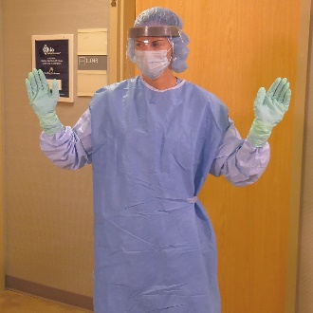
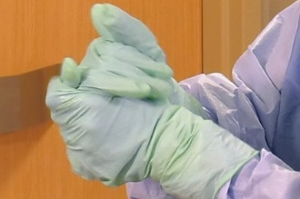
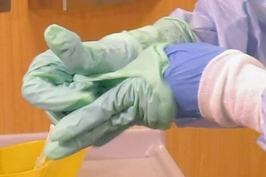
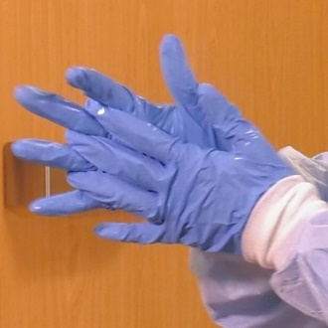

Remove the full face shield (leaving face mask or N95 respirator on if used) or remove PAPR
- Face shield
  - Tilt heat slightly forward, grasp rear strap, pull it gently over the head, allow the shield to fall forward, and discard.
  - Avoid touching the front surface of the face shield.
  - Do not touch the face when removing the face shield.
- PAPR with external belt-mounted blower (NOTE: if PAPR has self-contained blower in helmet, wait until step 13 to remove)
  - Remove PAPR tubing from hood first.
  - Remove PAPR hood by tilting the head slightly forward and allowing the hood to fall forward.
  - Remove the belt-mounted blower unit and place all reusable components in a designated area for disinfection.

Disinfect inner gloves
- Use a disinfectant wipe or ABHR and allow to dry.

Remove and discard hair cover (if used)
- Tilt head slightly forward, and pull the cover off.
- Discard in the designated waste container.

Disinfect inner gloves
- Use a disinfectant wipe or ABHR and allow to dry.

Remove gown
- Remove gown by untying or gently breaking fasteners.
- Pull gown away from body, folding inside out and touching only the inside of the gown.
- Avoid contact of scrubs or disposable garments with outer surface of gown during removal.
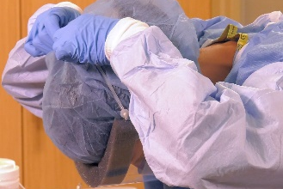
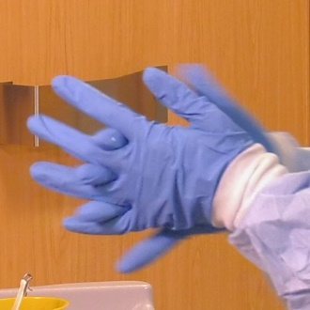
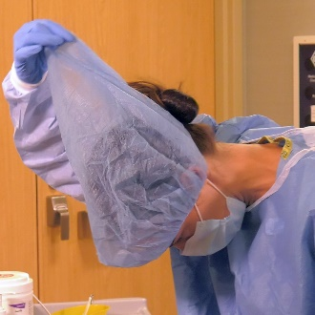
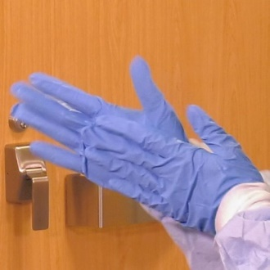

Disinfect inner gloves
- Use a disinfectant wipe or ABHR and allow to dry.

Remove protective booties (if used)
- Sit on a clean surface.
- Pull off shoe covers, taking care not to contaminate pant legs.

Disinfect and remove inner gloves
- Disinfect inner gloves with a disinfectant wipe or ABHR.
- Remove and discard gloves, taking care not to contaminate bare hands during removal process.

Perform hand hygiene
- Perform hand hygiene with ABHR.

Don a new pair of gloves

Remove face mask, N95 respirator, or PAPR that has a self-contained blower in the helmet
- Remove the surgical face mask or N95 respirator by tilting head slightly forward. Grasp the bottom elastic strap first, then the top elastic strap.
- Remove without touching the front of the surgical face mask or N95 respirator and discard in the designated waste container.
- If PAPR with self-contained blower in the helmet is used:
  - Remove and discard disposable component.
  - Disinfect inner gloves with a disinfectant wipe or ABHR.
  - Remove helmet and the belt and battery unit.
  - Place all reusable PAPR components in the designated collection area for disinfection.

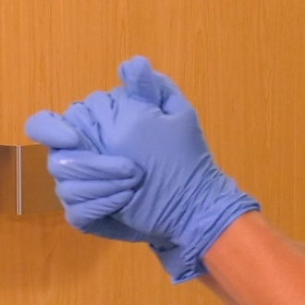
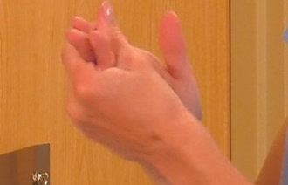

Disinfect and remove gloves
- Use a disinfectant wipe or ABHR and allow to dry.
- Remove and discard gloves, taking care not to contaminate bare hands during removal process.

Perform hand hygiene
- Perform hand hygiene with ABHR.

Inspect
- HCP and trained observer perform a final inspection for contamination of surgical scrubs or personal garments.
- If contamination is identified, HCP should shower immediately.
- Immediately inform infection preventionist, occupational health coordinator about the potential exposure.
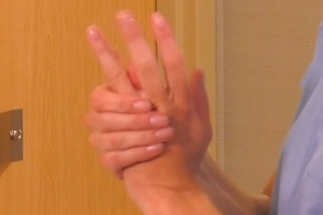
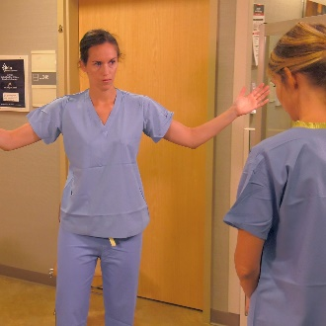

Resources
The instructions above are adapted from CDC For U.S. Healthcare Settings: Donning and Doffing Personal Protective Equipment (PPE) for Evaluating Persons Under Investigation (PUIs) for Ebola Who Are Clinically Stable and Do Not Have Bleeding, Vomiting, or Diarrhea (https://www.cdc.gov/vhf/ebola/healthcare-us/ppe/guidance-clinically-stable-puis.html).
CDC has short videos on donning and doffing each piece of PPE listed above.
- Visit CDC: Guidance for Donning and Doffing Personal Protective Equipment (PPE) During Management of Patients with Ebola Virus Disease in U.S. Hospitals (https://www.cdc.gov/vhf/ebola/hcp/ppe-training/index.html).
- Select type of PPE ensemble.
- Watch short video on donning or doffing individual piece of PPE.

Minnesota Department of Health
Infectious Disease Epidemiology, Prevention and Control
PO Box 64975
St. Paul, MN 55164-0975
651-201-5414
health.icar@state.mn.us
www.health.state.mn.us
09/2019
To obtain this information in a different format, call: 651-201-5414.

